SUPERIOR UNIVERSITY

Quantity Techniques in Business

Quantity Techniques in Business

SUBMITTED TO PROF .Illyas

BY

Abubaker 11353
Umer khan 11301
Umair Ali 11302
Hafiz.Saqib 11303

MBA (EVENING)
Section (A)

Determinants of GDP in AUSTRAILIA

Introduction:
Economic growth is an increase in real gross domestic product (GDP) (that is, GDP adjusted for inflation). The growth rate of real GDP is the percentage change in real GDP from one year to the next. Economic is a basic factor or component which effect directly to its country. One major area of research in economics is to identify the major factors that affect the economics of a country.
The economic growth is a complex phenomenon, which involves several factors. One of the major areas of research in economics has been to identify factors of economic growth. There is ample literature on the subject matter. These factors differ from country to country. If these factors can be identified, it can help to accelerate growth by focusing on the major leading sources of growth.
A sample of economic growth of Australia has been taken from World Development Indicators. Sample period of this country data 29 years selected for the period of 1980 to 2008 with annual frequency. In this study we select Country Australia topic we select GDP and one dependent variable and four independent variable select. Dependent variable is GGP deflator (inflation) and Independent variables are GDP growth (annual %), Money and quasi money (M2) as % of GDP, Imports of goods and services (% of GDP), Unemployment, total (% of total labor force).

Research Question:
What are the factors that affect economy of Australia?
What changes in these factors will cause to effect economy of Australia?

Objective of the Study:
The purpose behind the study is to know or to explore the determinants of GDP growth in Austrailia. In this study we select variables to investigate or to know about the dependency of GDP deflator on other four independent variable.

VARIABLES AND THEIR DEFINITIONS:

Dependent Variable:

GDP deflator (base year varies by country)
Indicator Name GDP deflator (base year varies by country).Short definition The GDP implicit deflator is the ratio of GDP in current local currency to GDP in constant local currency. The base year varies by country. Long definition The GDP implicit deflator is the ratio of GDP in current local currency to GDP in constant local currency. The base year varies by country.
Independent Variables:

1. GDP growth (annual %)
Annual percentage growth rate of GDP at market prices based on constant local currency. Aggregates are based on constant 2000 U.S. dollars. GDP is the sum of gross value added by all resident producers in the economy plus any product taxes and minus any subsidies not included in the value of the products. It is calculated without making deductions for depreciation of fabricated assets or for depletion and degradation of natural resources.
Long definition Annual percentage growth rate of GDP at market prices based on constant local currency. Aggregates are based on constant 2000 U.S. dollars. GDP is the sum of gross value added by all resident producers in the economy plus any product taxes and minus any subsidies not included in the value of the products. It is calculated without making deductions for depreciation of fabricated assets or for depletion and degradation of natural resources.

2. Money and quasi money (M2) as % of GDP
Money and quasi money comprise the sum of currency outside banks, demand deposits other than those of the central government, and the time, savings, and foreign currency deposits of resident sectors other than the central government. This definition of money supply is frequently called M2; it corresponds to lines 34 and 35 in the International Monetary Fund's (IMF) International Financial Statistics (IFS).
Long definition Money and quasi money comprise the sum of currency outside banks, demand deposits other than those of the central government, and the time, savings, and foreign currency deposits of resident sectors other than the central government. This definition of money supply is frequently called M2; it corresponds to lines 34 and 35 in the International Monetary Fund's (IMF) International Financial Statistics (IFS).

3. Imports of goods and services (% of GDP
Imports of goods and services represent the value of all goods and other market services received from the rest of the world. They include the value of merchandise, freight, insurance, transport, travel, royalties, license fees, and other services, such as communication, construction, financial, information, business, personal, and government services. They exclude compensation of employees and investment income (formerly called factor services) and transfer payments.
Long definition Imports of goods and services represent the value of all goods and other market services received from the rest of the world. They include the value of merchandise, freight, insurance, transport, travel, royalties, license fees, and other services, such as communication, construction, financial, information, business, personal, and government services. They exclude compensation of employees and investment income (formerly called factor services) and transfer payments.

4. Unemployment, total (% of total labor force)
Unemployment refers to the share of the labor force that is without work but available for and seeking employment. Definitions of labor force and unemployment differ by country.
Long definition Unemployment refers to the share of the labor force that is without work but available for and seeking employment. Definitions of labor force and unemployment differ by country.

Description of Cases:
A sample period of 29 years has been selected for this study for the period of 1980-2008 with annual frequency. Years for the staid period would be used as cases. So we have 29 cases.
Source of the Data:
http://data.worldbank.org/

QUALITY OF DATA:
The quality of data has been up to the mark no one value has been missing or it can be show accuracy. The data of dependent and independent variable show reliability and all independent variables have theoretically explanation that can effect on GDP deflator.

Descriptive Analysis:
We also in this study used the scatter diagrams to show the relationship between dependent and independent variables of Australia. Table of summary statistics is also included in this report to display the overall picture of the variables.
Justification of the Method:
Keeping in mind that the objective of this study, scatter plot diagram has been present to show the relationship between dependent and independent variables. There is a proper justified data we have been taken in this study. Scatter plots are especially useful when there are a large number of data points. It provides the following information about the relationship between two variables:
- Strength
- Shape - linear, curved, etc.
- Direction - positive or negative
- Presence of outliers

SUMMARY STATISTICS:

Table
 |  |  |  | GDP deflator (base year varies by country) | GDP growth (annual %) | Imports of goods and services (% of GDP) | Money and quasi money growth (annual %) | Unemployment, total (% of total labour force)
No of Observations |  |  | Valid | 1869 | 1869 | 1869 | 1869 | 1869
 |  |  | Missing | 0 | 0 | 0 | 0 | 0
Mean |  |  |  | 69.8937 | 3.4026 | 18.9759 | 12.1288 | 7.1413
Std. Error of Mean |  |  |  | .40397 | .03407 | .04702 | .15369 | .04366
Median |  |  |  | 70.1170 | 3.8300 | 19.5060 | 11.3690 | 6.9000
Mode |  |  |  | 100.00 | 3.73 | 21.61 | 14.21 | 8.50
Std. Deviation |  |  |  | 17.46559 | 1.47290 | 2.03308 | 6.64464 | 1.88749
Variance |  |  |  | 305.047 | 2.169 | 4.133 | 44.151 | 3.563
Skewness |  |  |  | -.339 | -1.813 | -.294 | 1.392 | .279
Std. Error of Skewness |  |  |  | .057 | .057 | .057 | .057 | .057
Range |  |  |  | 71.23 | 7.68 | 6.80 | 29.83 | 6.70
Minimum |  |  |  | 28.77 | -2.32 | 14.97 | 1.18 | 4.20
Maximum |  |  |  | 100.00 | 5.36 | 21.77 | 31.02 | 10.90
Sum |  |  |  | 130646.61 | 6360.19 | 35470.09 | 22671.43 | 13348.59
Percentiles |  | 25 |  | 62.5330 | 3.0440 | 16.8260 | 8.4300 | 5.8000
 |  | 50 |  | 70.1170 | 3.8300 | 19.5060 | 11.3690 | 6.9000
 |  | 75 |  | 80.8750 | 4.1400 | 20.8530 | 14.2100 | 8.5000

Explanation:
Table shows the summary statistics of the variables used in the study. These summary statistics reflect the overall picture of the variables. Above mention table show the summary statistics of dependent and independent variable. Actually this summary shows the reflection of variables. In above table we calculate averages(mean, median, mode, standard deviation), scenes, range and percentile of dependent and independent variables. Mostly the variable shows positive increase on averages. There is a negative sign show by GDP deflator, GDP growth and import of goods and services and remaining two variables show positive response. In above table show the percentile of dependent and independent variable and we take 75, 50, 25 percentiles.

Scatter-Plot Matrix

Figure 1 Figure 2
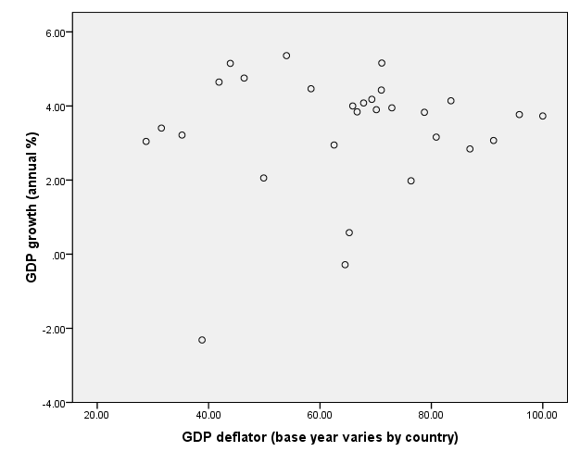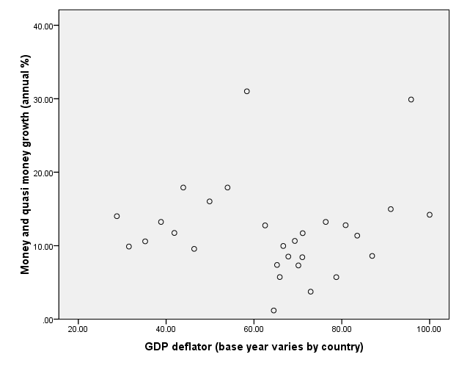

Figure 3 Figure 4
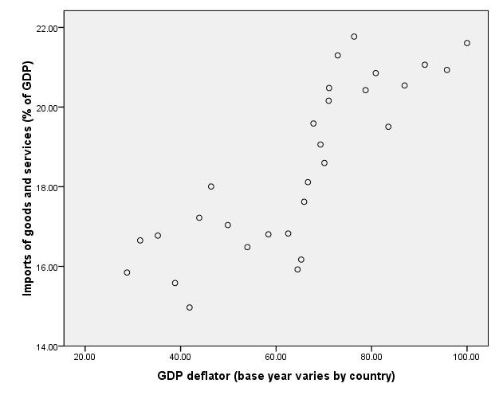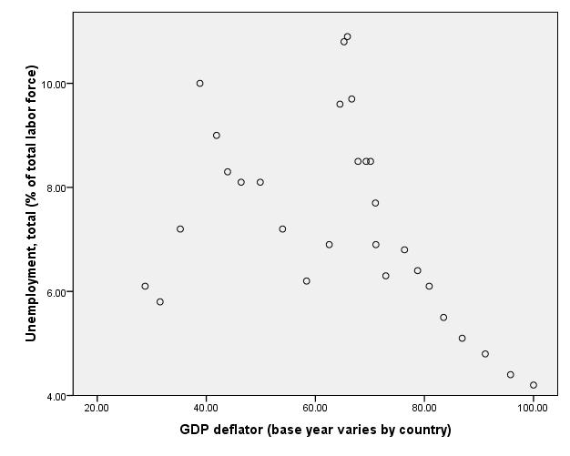

Summary and Conclusion

Figure 1 shows the relationship between GDP growth rate and GDP deflator. The diagram reflects or that show the positive effect of GDP growth rate on GDP deflator.The effect of money and quasar money growth (annual %) on GDP deflator shows positive effect in figure 2. In figure 3 shows that the effect of import of goods and services on GDP deflator there is rise in graph but at some points the graph slopes fall slightly down but overall result show positive. In figure 4 shows the effect of Unemployment of (total labor force) on GDP deflator negative effect, at starting point the plots show a slightly rise and go to at peak but after that the plots rapidly fall down.
The positive effect of independent variables means there is any increase in independent variables would be raise the value of dependent variable too, whereas it would happen reciprocally if the effect of independent variable on the dependent variable is negative.From the above analysis we conclude that GDP growth rate, money and quasi (m2), import of goods and services and unemployment are the important factor of economic growth of Australia.

References
- Bank national accounts data, and OECD National Accounts data files.
- http://en.wikipedia.org/Economy_of_india
- Definitions of the variables correspond to the World Bank national accounts data
- http://www.netmba.com/statistics/plot/scatter/
- Source OECD National Accounts data files.

