SUPERIOR UNIVERSITY

Financial management
SUBMITTED
TO
PROF .Mustafa
BY
Abu baker 11353
MBA (EVENING)
Section (A)

WHAT IS STOCK EXCHANGE?
A stock exchange, securities exchange is a corporation or mutual organization which provides "trading" facilities for stock brokers and traders, to trade stocks and other securities. Stock exchanges also provide facilities for the issue and redemption of securities as well as other financial instruments and capital events including the payment of income and dividends. Trade on an exchange is by members only. A stock exchange is often the most important component of a stock market. Supply and demand in stock markets is driven by various factors which, as in all free markets, affect the price of stocks.
Role of Stock exchange
The stock exchange admits companies for trading at their securities. It provides a market for raising capital by companies. It provides a market place for shares of listed public companies to be bought and sold, by bringing companies and investors together at one place. The exchange's role is to monitor the market to ensure that it is working efficiently, fairly and transparently.
What is SECP?
The Securities and Commission of Pakistan was setup in pursuance of (SECP) ACT, 1997. This act institutionalized certain policy decisions relating to constitutions and structure, powers, and functions of the SECP. The SECP became operational in January 1999 and has come a long way since then.
Visions
To develop modern and efficient corporate sector and also capital market based on sound regulatory principles.

Mission
To develop a fair, efficient, and transparent regulatory framework, based on international legal standards and best practices for the protection of investors.
Strategy
To develop an efficient and dynamic regulatory body that fosters principles of good governance in the corporate sectors and to ensure proper risk management procedures in the capital market or to protect investors through responsive policy measures and effective enforcement practices.
Types of Stock Exchanges
There are three stock exchanges in Pakistan.
1. Karachi stock exchange; formed in 1947
2. Lahore stock exchange; formed in 1971
3. Islamabad stock exchange; formed in 1989

Lahore Stock Exchange
Lahore Stock Exchange was established in October 1970 and is the second largest stock exchange in the country with a market share of around 12-16% in terms of daily traded volumes. LSE has 497 listed companies, spanning 37 sectors of the economy, that are listed on the Exchange with total listed capital of Rs. 850 billion having market capitalization of around Rs. 3.134 trillion as on February 14,2011. LSE has 152 members of whom 81 are corporate and 54 are individual members.
Over the years, LSE has successfully met various challenges and has now emerged, fully positioned to aggressively compete with its fellow Exchanges, contributing towards the growth of Capital Markets in Pakistan.

History of Lahore Stock exchange
Lahore Stock Exchange (Guarantee) Limited came into existence in October 1970, under the Securities and Exchange Ordinance, 1969, of the Government of Pakistan. It initially had 83 members and was housed in a rented building in the crowded Bank Square area of Lahore. The number of listed companies has increased to 519 since its inception. With 37 sectors of economy and 519 listed companies with total capital of Rs.555.67 billion having market capitalization of around Rs. 3.164 trillion. LSE has152 members of whom 81 are corporate 54 are individual members. After construction of its own building located at 19-Khayaban-e-Aiwan-e-Iqbal, Lahore, there was sufficient space, modern facilities, and all the needed communications at this new location. LSE was first stock exchange of Pakistan which used internet and currently 50% of its transactions are done on internet.
LSE Index
LSE-25: The Lahore Stock Exchange Twenty Five company index also calculates the performance of stocks assuming that all rights issues and bonus share issues only increase the listed capital. However, the LSE25 assumes that dividends paid out by a component company are not reinvested. In summary, in the LSE25, no price adjustments are made when any component company issues cash dividends.
The Lahore Stock Exchange Total Return Index calculates the performance of stocks assuming that all payouts are reinvested in the index on the ex-date. The LSETRI assumes that if a component company issues bonus shares or announces a rights issue it will increase the listed capital. Additionally, the LSETRI also assumes that all pay-outs by a component company are 100% reinvested in the index.
WHAT ARE STOCKS?
Stocks are the shares in the ownership of a company. Stock represents a claim on the company's assets and earnings. Stockholders are the investors and become the owners of the company. Whether you can say shares, equity, or stock, it all means the same thing. But now-a-days you can get this document because brokers keep these records electronically.
Types of traded stocks
1. COMMON STOCKS:
2. PREFERRED STOCKS:
COMMON STOCKS
Mostly companies issue common stocks. It can be issued more than or less than face value. Face value of common stock always 10.Dividend on it is not fixed and Common Stock holders are the true owner of the company. They have the voting right to select the management.
PREFERRED STOCKS
Preferred stocks are issued by very small number of companies. It has been given against the common stock in terms of dividend and in case of bankruptcy. Dividend on P/S is clearly stated in terms of either in % or either in amounts.
There are four types of P/S:
- Accumulated
- Non Accumulated
- Participant
- Non Participant
Central Depository Company (CDC)
With the introduction of the Central Depository System (CDS), an investor can have shares in paper form or can own shares in an electronic book- entry form at the Central Depository Company (CDC).
Cap and floor
Cap means we add 1 or 5 in share price and floor means we subtract 1 or 5 from share price. If share price is less than 20 then we add or less 1 and if share price is more than 20 then we add or subtract 5 from the share price.
Bid and ask
The "bid" is the current highest price at which you could sell. In the other word, if you want to sell your gold, in generally, you can sell it closest to the bid price but not the bid price whereas ask is opposite of the bid. The "ask" is the current lowest price at which you could buy. As a rule, you buy it often higher than the ask price.

Red, Blue and Green colors
Red means price of share below the original face value
Blue means the price of share is unchanged
Green means share price increase its face value
Index
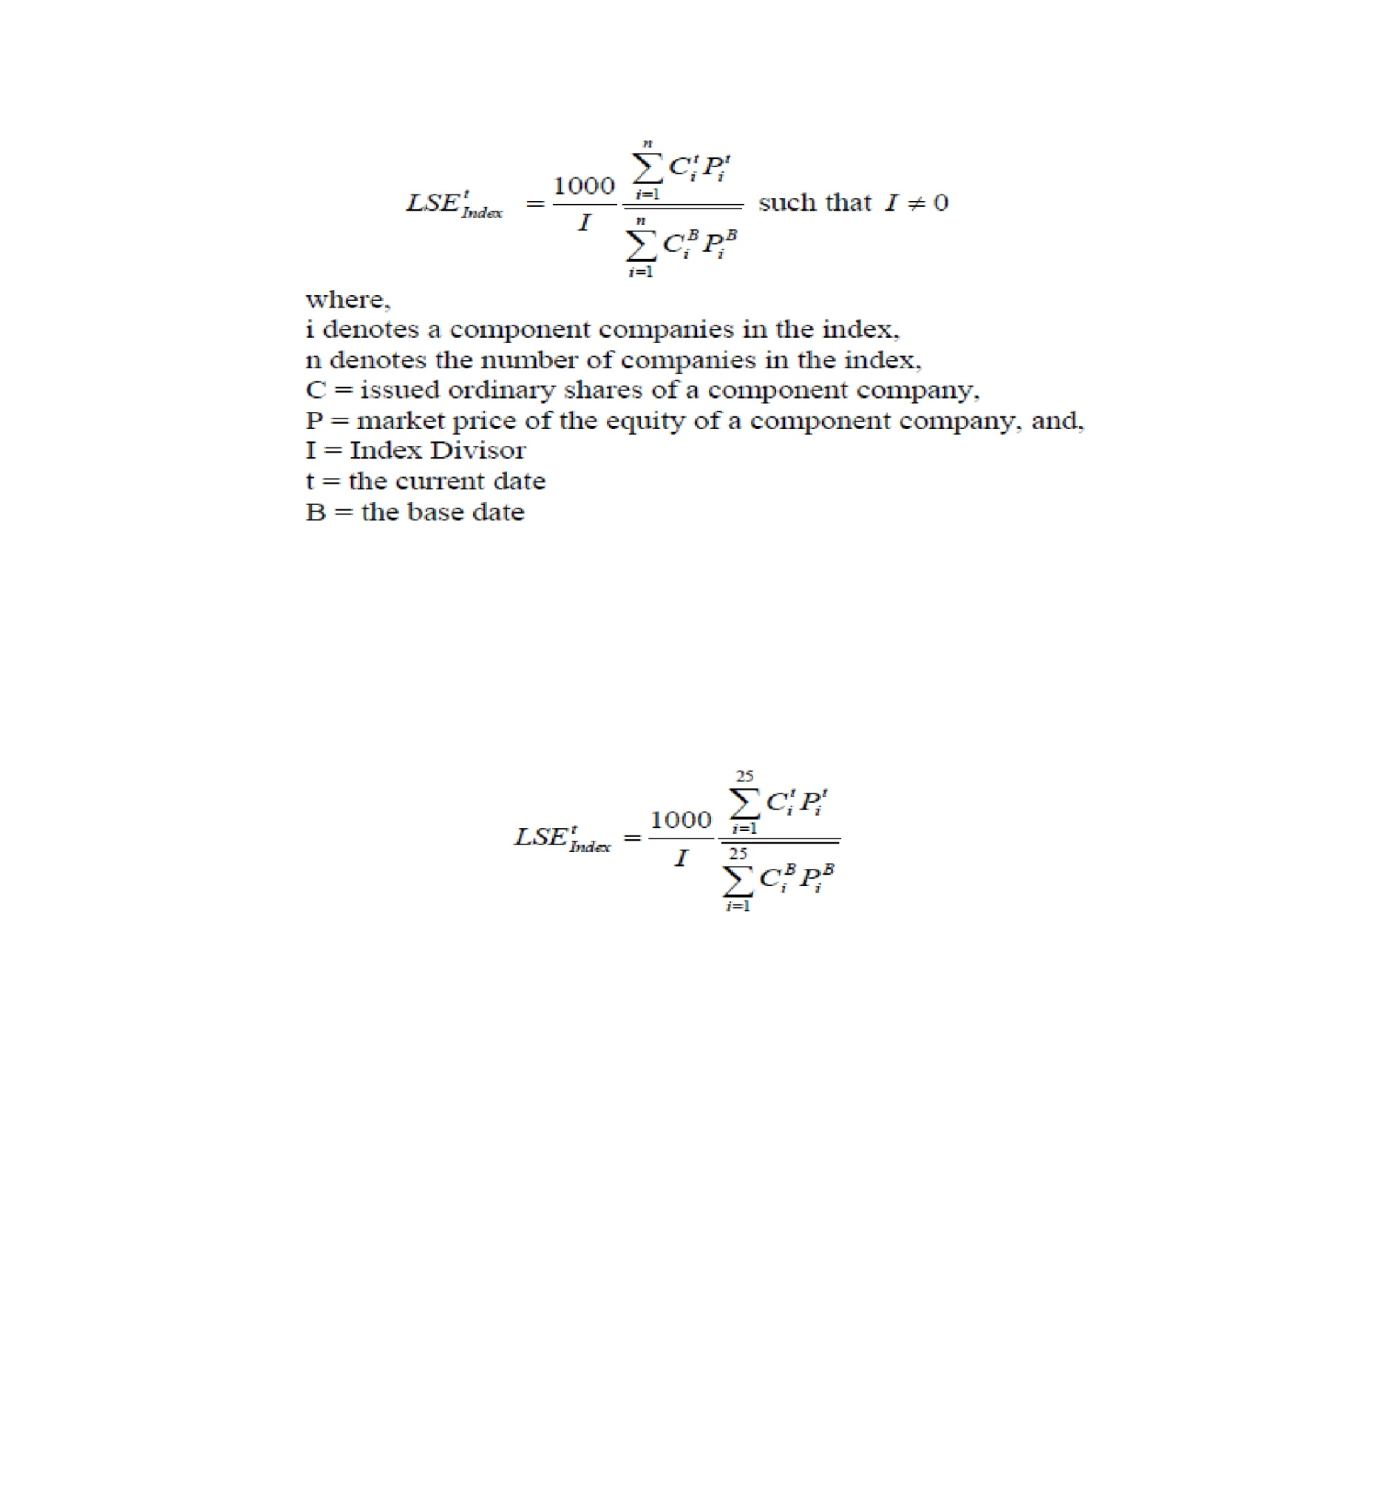
Every day in business news it is heard that KSE 100 Index or LSE 25 Index increased or decreased by some points. Index shows the trade of shares of top companies in the market. In Karachi Stock Exchange 100 index shows the trade of shares of top 100 companies in the market. Lahore stock exchange index shows the top 25 companies’ shares.

Dividend
Dividends are the profit which can be paid by the company to its share holder.
How account has been opened?
If an investor wants to purchase the shares of a particular company, he has to open an account with the Broker in the Stock Exchange. On the other hand the broker has the account and registered with the Stock Exchange. The registration fee is Rs.4 Million and broker is allowed to trade up to 25 times of his Net Capital. Investor can order in two ways.
How Shares are traded?
Clients can purchase shares from their brokers on debt but it is necessary by SECP that client should pay at least 60% of the amount.
Computerized trading system:
The stock exchanges have introduced a computerized trading system to provide a fair, transparent, efficient and cost effective market mechanism to facilitate the investors. Before this system stocks were traded physically by bidding in the open hall which was very slow system.
IT software
In Pakistan LSE is the first to introduce IT trading system, in which software” ULTRA” is used. The trading system comprises of four distinct segments, which are:
- T+3 Settlement System,
- Provisionally Listed Counter,
- Spot Transactions,
- Futures Contracts.

WHAT IS SHARE?
The total capital of the company is divided into small units each unit is called share.
Types of shares:
- Preference Shares:
These are shares whose holders have preferential rights in respect of the payment of dividend and repayment of capital in the event of winding up. The rate of dividend on these shares is fixed.
There are further two types of preference shares.
- Cumulative preference shares
- Non-Cumulative preference shares
Cumulative preference shares:
If the profit of company is not enough to pay dividend on any kind of
shares at the end of financial year than the right of dividend on these shares accumulates until all arrears of unpaid dividend have been paid.
Non-Cumulative preference shares:
These are the shares on which dividend is not paid out of current year’s profit in any year then it is never paid.
- Ordinary Shares:

These shares are the shares on which dividend is not paid at fixed rate. Ordinary shareholders receive the dividend proportionally out of profit earned by the company after the payment of fixed dividend on preference shares.
- Deferred Shares:
The share issued to promoters of the company is called deferred shares. The dividend on these shares is paid after the payment of dividend on all other types of share.

Operators who buy and sell securities on stock exchange
a)Brokers:
A broker is a member of the stock exchange. He buys and sells the securities on the behalf of the outsiders who are not the members. He charges commission for his services. He does not specialize in any particular security.
He buys sells all types of securities according to the orders placed by his clients.
b) Jobbers:
The jobber is a member of stock exchange but he buys and sells securities on his own behalf. He is dealer insecurities. He usually specializes in one type of security. His income comes from the profit or price difference in the purchase and sale of securities.
c) Bulls:
A bull is a speculator who expects a rise in prices. Therefore, he buys securities with a view to sell them in future at a higher price thereby make profit.
d) Bears:
A bear is a speculator expects fall in prices. Therefore, he sells securities for future delivery. He sells securities, which he does not possess. He sells with the hope to buy the securities at lower price before the date of delivery.
Role of Stock Exchange in economy:
Stock exchanges have multiple roles in the economy,
This may include the following:
- Raising capital for businesses:
The Stock Exchange provides companies with the facility to raise capital for expansion through selling shares to the investing public. It induces people to save and invest in securities. People know that when they need money, they can easily sell their securities on stock exchange. Therefore, they are more willing to invest their savings in securities. Thus a stock exchange serves as an instrument for raising capital.
- Mobilizing savings for investment:

When people draw their savings and invest in shares, which could have been consumed, or kept in idle deposits with banks, are mobilized to promote business activity with the benefits of several economic sectors such as agriculture, commerce and industry, resulting in stronger economic growth and higher productivity levels.
- Facilitating company growth:
Companies view acquisitions as an opportunity to expand product lines, increase distribution channels, increase its market shares, or acquire other necessary business assets. A takeover bid or a merger agreement through the stock market is one of the simplest and most common ways for a company to grow by acquisition.
- Investment opportunities for small investors:
The Stock Exchange provides the opportunity for small investors to own shares of the same companies as large investors.
- Government capital-raising for development projects:
Governments at various levels may decide to borrow money in order to finance infrastructure projects such as sewage and water treatment works or housing estates by selling another category of securities, known as bonds.
These bonds can be raised through the Stock Exchange whereby members of the public buy them, thus loaning money to the government. The issuance of such bonds to remove the need to directly tax the citizens in order to finance development, although by securing such bonds with the full faith and credit of the government instead of with side by side, the result is that the government must tax the citizens or otherwise raise additional funds to make any regular coupon payments and refund the principal when the bonds mature.

- Barometer of the economy:
At the stock exchange, share prices rise and fall depending, largely, on market forces. Share prices tend to riser remain stable when companies and the economy in general show signs of stability and growth. An economic recession, depression, or financial crisis could eventually lead to a stock market crash.
Lahore Stock Exchange
Type | Stock Exchange
Location | Lahore, Pakistan
Founded | 1970
Owner | Lahore Stock Exchange Limited
Key people | Arif Saeed(Chairman)
Currency | PKR
No. of listings | 671
MarketCap | US$ 73 billion
Volume | US$ 12 billion.
Indexes | LSE 25 Index

Functions Performing
Lahore stock exchange:
Although the Lahore stock exchange market has various functions, its main activities are two:
1. To promote the savings and for them to be canalized towards of carrying through investment projects that otherwise wouldn’t be possible you need that the issuing institution of the securities to be admitted for quoting. The negotiations will be done on the primary market.
2. To provide liquidity to the investors. The investor can recuperate the money invested when needed. For it, he has to go to the Lahore stock exchange market to sell the securities previously acquired. This function of the stock market is done on the secondary market.
Other functions of the LSE market as an organization are:
- To guarantee the legal and economic security.
- To provide official information about the quantities that is negotiated.
- To fix the prices of the securities according to the fundamental law of the offer and the demand.
Functions done by the LSE market in favor of the investor:
- It permits him the access to the profitable activities of the big companies.
- It offers liquidity to the security investments, through a place in which to sell or buy securities.
- It permits for the investor to have a political power in the companies
- It offers the possibility of diversifying your portfolio by enlarging the field.
Function done by the LSE market in favor of the companies:
- It supplies them with the obtaining of long-term funds that permits the company to make profitable activities or to do determine projects that otherwise wouldn’t be possible to develop for lack of financing. Also, this funding signifies a less cost than if obtained at other channels.
- The securities quoted at the Lahore stock exchange market usually have more fiscal purpose advantages for the companies.
- It offers to the company’s free publicity, which in other way would suppose considerable expenses. The institution is objecting of attention of the media (television, radio, etc.) in case any important change in its owners (the share holders)
Other Function of the Lahore stock exchange:
- Raising capital for businesses
- Mobilizing saving for investment
- Facilitating company growth
- Redistribution of wealth
- Corporate governance
- Creating investment opportunity of small investor
- Govt. capital- raising for development project
- Barometer of the economy

LSE's BOARD OF DIRECTORS-2011

Mr. Aftab Ahmad Khan Chairman
(Group Director (Finance & Accounts), Nishat Group, Nishat)

Mr. Jahanzeb Mirza
(Nominee S. D. Mirza Securities (Pvt.) Ltd. Room No. 401, 4th Floor , LSE Building )

Mr. Aftab Ahmad Ch.
(Managing Director/CEO Lahore Stock Exchange )

Mr. Ammar-ul-Haq
(Nominee Director)

Mirza Ejaz Ullah Baig
(Nominee Director M/S. CAPITAL VISION SECURITIES (PVT.) LTD.)

Mr. Asif Kamal
(Chairman, Trust Investment Bank Limited 8-K )

Mr. Mumtaz Hussain Syed
(Chief Executive, Crosby Capital Pakistan (Private) Limited)

Ms. Bushra Naz Malik

(Nominee Director)

Mr. Naeem Anwar
(Director MAAN Securities (Pvt.) Ltd.)

References:
BILAL BUTT
OPERATOR in Pearl brokerage (p v t) Limited.
ROOM M-5, Floor mezzanine, LSE
www.pearlbrokerage.com.pk
M.IRFAN
Operator in Stock Master Securities (p v t) Limited
ROOM M-10, Floor mezzanine, LSE.
www.stockmaster.com.pk
www.secp.gov.pk
www.Lse.com.pk

