SUPERIOR UNIVERSITY

Quantity Techniques in Business

PRESENTED
TO
Prof .Illyas
BY
Abu baker 11353
Umer khan 11301
Umair Ali 11302
Hafiz Saqib 11303
Fakher 11311

MBA (EVENING)
Section (A)

Determinants of GDP in AUSTRAILIA

Introduction:
The economy of Australia is a developed, modern market economy with a GDP of approximately US$1.2 trillion. In 2009, it was the 13th largest national economy by nominal GDP representing about 1.7% of the World economy. Australia was also ranked the 19th largest importer and 19th largest exporter. Economic growth is an increase in real gross domestic product (GDP) (that is, GDP adjusted for inflation). The growth rate of real GDP is the percentage change in real GDP from one year to the next. Economic is a basic factor or component which effect directly to its country. One of the most important areas of determinant of GDP in Australia is to identify the major factors. These factors are both direct and indirect, and internal and external and they differ from country to country. Due to the different socioeconomic conditions the factors of economic growth may be different in the cases of developing and developed countries. One major area of research in economics is to identify the major factors that affect the economics of a country.
The economic growth is a complex phenomenon, which involves several factors. One of the major areas of research in economics has been to identify factors of economic growth. There is ample literature on the subject matter. These factors differ from country to country. If these factors can be identified, it can help to accelerate growth by focusing on the major leading sources of growth. A sample of economic growth of Australia has been taken from World Development Indicators. Sample period of this country data 29 years selected for the period of 1980 to 2008 with annual frequency. In this study we select Country Australia topic we select GDP and one dependent variable and four independent variable select. Dependent variable is GGP deflator (inflation) and Independent variables are GDP growth (annual %), Money and quasi money (M2) as % of GDP, Imports of goods and services (% of GDP), Unemployment, total (% of total labor force).
Research Question:
How does the GDP deflator of Australia, annual% growth rate, Money and quasi money, Imports of goods and services, Unemployment, total % of total labor force affect the GDP growth rate in Australia?
Objective of the Study:
The purpose behind the study is to know or to explore the determinants of GDP growth in Australia. In this study we select variables to investigate or to know about the dependency of GDP deflator on other four independent variable.

Data and Methodology
Data
Sample period of this country data 29 years selected for the period of 1980 to 2008 with annual frequency. The Data depending availability has been show with the longest possible period values and avoid smallest period values. The data of all variables has been selected from World Development Indicators. In this study we have been selected five variables one is dependent and remaining have been independent.
Here growth domestic product deflator base year (GDPD) varies by country has been taken as dependent variable to represent the economic growth whereas growth rate annual% of gross domestic product (GGDP), Money and quasi money (m2), Imports of goods and services, Unemployment (total % of total labor force). The dependent and independent variables and their descriptions have been given below:
Dependent Variable:
GDP deflator (base year varies by country)
Indicator Name GDP deflator (base year varies by country).Short definition The GDP implicit deflator is the ratio of GDP in current local currency to GDP in constant local currency. The base year varies by country. Long definition The GDP implicit deflator is the ratio of GDP in current local currency to GDP in constant local currency. The base year varies by country.
Independent Variables:
1. GDP growth (annual %)
Annual percentage growth rate of GDP at market prices based on constant local currency. Aggregates are based on constant 2000 U.S. dollars. GDP is the sum of gross value added by all resident producers in the economy plus any product taxes and minus any subsidies not included in the value of the products. It is calculated without making deductions for depreciation of fabricated assets or for depletion and degradation of natural resources.
Long definition Annual percentage growth rate of GDP at market prices based on constant local currency. Aggregates are based on constant 2000 U.S. dollars. GDP is the sum of gross value added by all resident producers in the economy plus any product taxes and minus any subsidies not included in the value of the products. It is calculated without making deductions for depreciation of fabricated assets or for depletion and degradation of natural resources.

2. Money and quasi money (M2)
Money and quasi money comprise the sum of currency outside banks, demand deposits other than those of the central government, and the time, savings, and foreign currency deposits of resident sectors other than the central government. This definition of money supply is frequently called M2; it corresponds to lines 34 and 35 in the International Monetary Fund's (IMF) International Financial Statistics (IFS).
Long definition Money and quasi money comprise the sum of currency outside banks, demand deposits other than those of the central government, and the time, savings, and foreign currency deposits of resident sectors other than the central government. This definition of money supply is frequently called M2; it corresponds to lines 34 and 35 in the International Monetary Fund's (IMF) International Financial Statistics (IFS).
3. Imports of goods and services
Imports of goods and services represent the value of all goods and other market services received from the rest of the world. They include the value of merchandise, freight, insurance, transport, travel, royalties, license fees, and other services, such as communication, construction, financial, information, business, personal, and government services. They exclude compensation of employees and investment income (formerly called factor services) and transfer payments.
Long definition Imports of goods and services represent the value of all goods and other market services received from the rest of the world. They include the value of merchandise, freight, insurance, transport, travel, royalties, license fees, and other services, such as communication, construction, financial, information, business, personal, and government services. They exclude compensation of employees and investment income (formerly called factor services) and transfer payments.
4. Unemployment, total (% of total labor force)
Unemployment refers to the share of the labor force that is without work but available for and seeking employment. Definitions of labor force and unemployment differ by country.Long definition Unemployment refers to the share of the labor force that is without work but available for and seeking employment. Definitions of labor force and unemployment differ by country.
Quality of Data:
The quality of data has been up to the mark no one value has been missing or it can be show accuracy. The data have been collected according to the above definition of variables; the data used in this study is valid for the purpose of analysis. The data of dependent and independent variable show reliability and all independent variables have theoretically explanation that can effect on GDP deflator. It is important to note that the above variable definitions have been taken from the World Development Indicator which is the source of data that has been used in this research study. There is no data of all dependent and independent variables are missing. The data on World Development Indicators are drawn from the sources thought to be most reliable.
Methodology:
In this research study we use descriptive statistics and inferential statistics. The scatter-plot has been used to explore the dependent and independent variables. A table of correlation has been used in which we select Pearson correlation sig (2 tailed) and n also a part of this research study and that table provides the signs and values of coefficient of correlation. This table also provides the P-values of the test of the null hypothesis which states that the said variables are not correlated to each other.
Justification of the Method:
Keeping in mind that the objective of this study, scatter plot diagram has been present to show the relationship between dependent and independent variables. There is a proper justified data we have been taken in this study. Magnitudes and signs of the correlation coefficients are provided in the table of correlations. There is a proper justification done with this research study. Most of the methods have been used to explore this study for that we use spss software that has been clearly define the dependent and independent variables. This table also provides the P-values of the test of the null hypothesis that states that there is no correlation between two variables.
Method of multiple-regression is used to estimate the effect of multiple predictors on the predicted. Considering the objective of this study the multiple-regression analysis is used in this study to estimate the partial regression coefficients of the independent variables and their statistical significance. We have used the method of multiple-regression because there are five independent variables in this study and all of them are scale variables.
Scatter plots are especially useful when there are a large number of data points. It provides the following information about the relationship between two variables:
- Strength
- Shape - linear, curved, etc.
- Direction - positive or negative
- Presence of outliers

- Empirical Findings
In this part of the study empirical findings have been shown and that can be interpreted. The following table presents the descriptive statistics which show the overall picture of the variables.
Table 1.1
Descriptive Statistics
 | N | Minimum | Maximum | Mean | Std. Deviation
GDP deflator (base year varies by country) | 1869 | 28.77 | 100.00 | 69.8937 | 17.46559
GDP growth (annual %) | 1869 | -2.32 | 5.36 | 3.4026 | 1.47290
Imports of goods and services (% of GDP) | 1869 | 14.97 | 21.77 | 18.9759 | 2.03308
Money and quasi money growth (annual %) | 1869 | 1.18 | 31.02 | 12.1288 | 6.64464
Unemployment, total (% of total labor force) | 1869 | 4.20 | 10.90 | 7.1413 | 1.88749
Valid N (list wise) | 1869

In the above mention table we discuss minimum values, maximum values, mean and standard deviation of all five variables. Mean value provides the idea about the central tendency of the values of a variable. Number of observations of each variable is 1869. Standard deviation and the extreme values minimum values compare with maximum values and give the idea about the dispersion of the values of a variable from its mean value. The units of different measures have been used for different variables the dispersion of a variable using standard deviation can’t be compared with other variable unless both variables have the same unit of measure but still these statistics are helpful to have an idea about the central tendency and the dispersion of a variable in absolute terms rather than relative terms. Actually in the above table we conclude that there is a relationship of economic growth of Australia with both of dependent and four independent variables.
Figure 1.2
Scatter-Plot Matrix
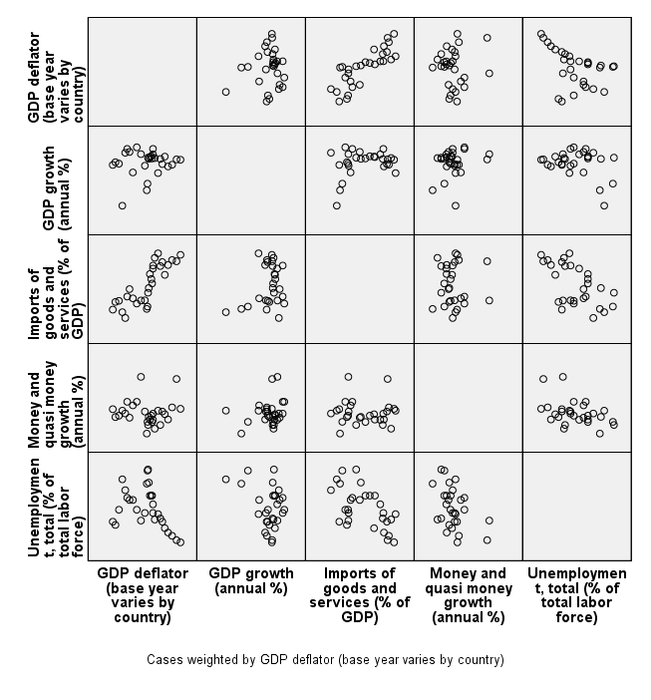

Table 1.3
Correlations
 |  | GDP deflator (base year varies by country) | GDP growth (annual %) | Imports of goods and services (% of GDP) | Money and quasi money growth (annual %) | Unemployment, total (% of total labor force)
GDP deflator  (base year varies by country) | Pearson Correlation | 1 | .094^{(**)} | .821^{(**)} | .129^{(**)} | -.586^{(**)}
 | Sig. (2-tailed) |  | .000 | .000 | .000 | .000
 | N | 1869 | 1869 | 1869 | 1869 | 1869
GDP growth  (Annual %) | Pearson Correlation | .094^{(**)} | 1 | .267^{(**)} | .218^{(**)} | -.280^{(**)}
 | Sig. (2-tailed) | .000 |  | .000 | .000 | .000
 | N | 1869 | 1869 | 1869 | 1869 | 1869
Imports of goods and services  (% of GDP) | Pearson Correlation | .821 ^{(**)} | .267^{(**)} | 1 | .059* | -.657^{(**)}
 | Sig. (2-tailed) | .000 | .000 |  | .011 | .000
 | N | 1869 | 1869 | 1869 | 1869 | 1869
Money and quasi money growth (annual %) | Pearson Correlation | .129^{(**)} | .218^{(**)} | .059^{(*)} | 1 | -.460^{(**)}
 | Sig. (2-tailed) | .000 | .000 | .011 |  | .000
 | N | 1869 | 1869 | 1869 | 1869 | 1869
Unemployment, total (% of total labor force) | Pearson Correlation | -.586^{(**)} | -.280^{(**)} | -.657^{(**)} | -.460^{(**)} | 1
 | Sig. (2-tailed) | .000 | .000 | .000 | .000
 | N | 1869 | 1869 | 1869 | 1869 | 1869

Correlation is significant at the 0.01 level (2-tailed).
Correlation is significant at the 0.05 level (2-tailed).

Table 1.4
Regression
Model |  | Coefficients | Std. Error | t-test |  | Sig. Level
1 | (Constant) |  | 4.234 |  | -14.177 | .000
 | GDP growth (annual %) | -.163 | .159 |  | -11.973 | .000
 | Imports of goods and services (% of GDP) | .833 | .156 |  | 45.783 | .000
 | Money and quasi money growth (annual %) | .097 | .041 |  | 6.299 | .000
 | Unemployment, total (% of total labor force) | -.038 | .187 |  | -1.896 | .058

Dependent variable: GDP Growth (Annual %)

Table 1.5
Necessary Statistics
Coefficient of  Determination (R²) | Adjusted Coefficient of  Determination (Adj. R²) | Durbin-Watson Statistic | F-Statistic | Sig. (F-Stat)
.704 | .703 | .^{b} | 1108.027 | .000

R | R Square | Adjusted R Square | Std. Error of the Estimate | F-Statistics
.094 | .009 | .008 | 17.392 | 16.763
The independent variable is GDP growth (annual %).

Figure 1.6
Plot of Residuals against Fitted Values for the Economic Growth Data
Summary and Conclusion

